ReSpectacle Boxes
Duke Eye Center | Box Location | Picture | Contact person(s) | ReSpectacle Champion individual to bring glasses to central location
Holly Springs | On ledge underneath TV | 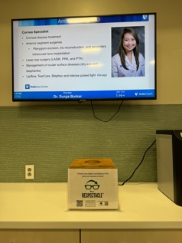 | Amanda Mestler  Lyle Collin | TBD
Cary | On table underneath TV | 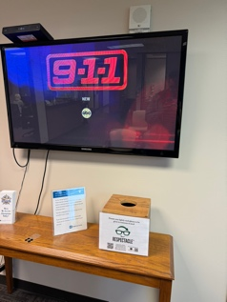 | Amanda Mestler | TBD
Raleigh | On ledge underneath TV | 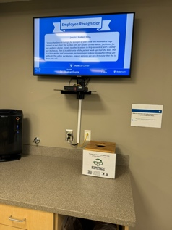 | Christy Pennix | TBD
Arringdon | On ledge underneath to the left of entrance | 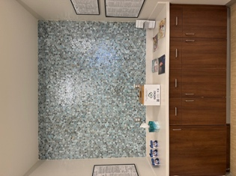 | Chelsea Shearer | TBD
South Durham | On ledge underneath TV | 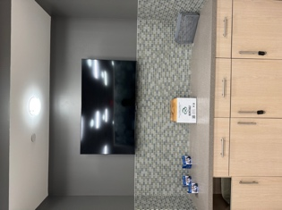 | Chelsea Shearer  Peter Chan | TBD
Main | On Ambassador Desk | 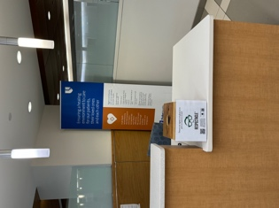 | Amy Gentry-Long | TBD

